**LAB REPORT**

***Submitted by***

**THRIDEEP.S (RA2111032010003)**

***Under the Guidance of***

**Dr. Gouthaman. P**

**Assistant Professor, Department of Networking and Communications**

***In partial satisfaction of the requirements for the degree of***

**BACHELOR OF TECHNOLOGY**

in

**COMPUTER SCIENCE AND ENGINEERING**

**with specialization in Internet of Things**



**SCHOOL OF COMPUTING**

**COLLEGE OF ENGINEERING AND TECHNOLOGY SRM INSTITUTE OF SCIENCE AND TECHNOLOGY KATTANKULATHUR - 603203**

**MAY 2023**

|  |  |
| --- | --- |
|  | COLLEGE OF ENGINEERING & TECHNOLOGY SRM INSTITUTE OF SCIENCE & TECHNOLOGY  S.R.M. NAGAR, KATTANKULATHUE – 603 203  Chengalpattu District |

**BONAFIDE CERTIFICATE**

Register No. RA2111032010003 Certified to be the

bonafide work done by Thrideep.S of II Year/IV Sem B.Tech Degree Course in the **Practical Course – 18CSC206J - Software Engineering and Project Management** in **SRM INSTITUTE OF SCIENCE AND TECHNOLOGY,** Kattankulathur during the academic year 2022 – 2023.

|  |  |
| --- | --- |
| **SIGNATURE**  Faculty In-Charge **Dr. Gouthaman. P** Assistant Professor  Department of Networking and Communications SRM Institute of Science and Technology | **SIGNATURE**  **HEAD OF THE DEPARTMENT**  **Dr. Annapurani Panaiyappan. K**  Professor and Head,  Department of Networking and Communications SRM Institute of Science and Technology |

i

**ABSTRACT**

An online doctor appointment booking system is a web-based platform designed to simplify the process of scheduling medical consultations with healthcare professionals. The system enables patients to book appointments with doctors or specialists online, eliminating the need for lengthy

phone calls or in-person visits to schedule appointments.

The system is built with various features, including the ability to search for doctors by specialty, location, availability, and other criteria. Patients can view the profiles of doctors, read reviews and ratings, and select the most suitable practitioner for their needs.

The platform is designed to be user-friendly, allowing patients to easily navigate through the booking process, select the appointment date and time, and make payments online. Patients can also receive reminders and notifications for their appointments, which can help reduce no-shows and improve overall patient satisfaction.

Doctors and healthcare providers can also benefit from this system by having a centralized platform to manage their appointments, view their schedules, and communicate with patients. The system can also help healthcare providers to optimize their scheduling, reduce wait times, and improve the efficiency of their practices.

Overall, an online doctor appointment booking system is an effective solution for simplifying the appointment scheduling process, enhancing patient experiences, and improving the overall efficiency of healthcare delivery.

ii

**TABLE OF CONTENTS**

|  |  |  |
| --- | --- | --- |
| **EXP NO** | **TITLE** | **PAGE NO** |
|  | **ABSTRACT** | ii |
|  | **LIST OF FIGURES** | iv |
|  | **LIST OF ABBREVIATIONS** | v |
| **1** | **PROBLEM STATEMENT** | 1 |
| **2** | **STAKEHOLDERS & PROCESS MODELS** | 5 |
| **3** | **IDENTIFYING REQUIREMENTS** | 8 |
| **4** | **PROJECT PLAN & EFFORT** | 11 |
| **5** | **WORK BREAKDOWN STRUCTURE & RISK ANALYSIS** | 15 |
| **6** | **SYSTEM ARCHITECTURE, USE CASE & CLASS DIAGRAM** | 22 |
| **7** | **ENTITY RELATIONSHIP DIAGRAM** | 25 |
| **8** | **DATA FLOW DIAGRAM** | 28 |
| **9** | **SEQUENCE & COLLABORATION DIAGRAM** | 32 |
| **10** | **DEVELOPMENT OF TESTING FRAMEWORK/USER INTERFACE** | 35 |
| **11** | **TEST CASES & REPORTING** | 39 |
| **12** | **ARCHITECTURE/DESIGN/FRAMEWORK/IMPLEMENTATION** | 42 |
|  | **CONCLUSION** |  |
|  | **REFERENCES** |  |

iii

**LIST OF FIGURES**

|  |  |  |
| --- | --- | --- |
| **FIGURE NO** | **TITLE** | **PAGE NO** |
| 5.1 | Work Breakdown Structure | 16 |
| 5.2 | Gantt Chart | 17 |
| 6.1 | Architecture Diagram | 23 |
| 6.2 | Use Case Diagram | 24 |
| 6.3 | Class Diagram | 25 |
| 7.1 | Entity Relationship Diagram | 26 |
| 8.1 | Data Flow Diagram Level 0 | 29 |
| 8.2 | Data Flow Diagram Level 1 | 30 |
| 9.1 | Collaboration Diagram | 33 |
| 9.2 | Sequence Diagram | 34 |
| 12.1 | Book an Appointment UI | 43 |
| 12.2 | Cancellation of Appointment UI | 44 |
| 12.3 | Payment UI | 45 |

iv

**LIST OF ABBREVIATIONS**

|  |  |
| --- | --- |
| **Abbreviation** | **Meaning** |
| UI | User Interface |
| UX | User Experience |
| WBS | Work Breakdown Structure |
| SWOT | Strength, Weakness, Opportunities and Threats |
| RMMM | Risk Management, Monitoring, and Mitigation |
| API | Application Programming Interface |
| ER | Entity Relationship |
| DFD | Data Flow Diagram |

V

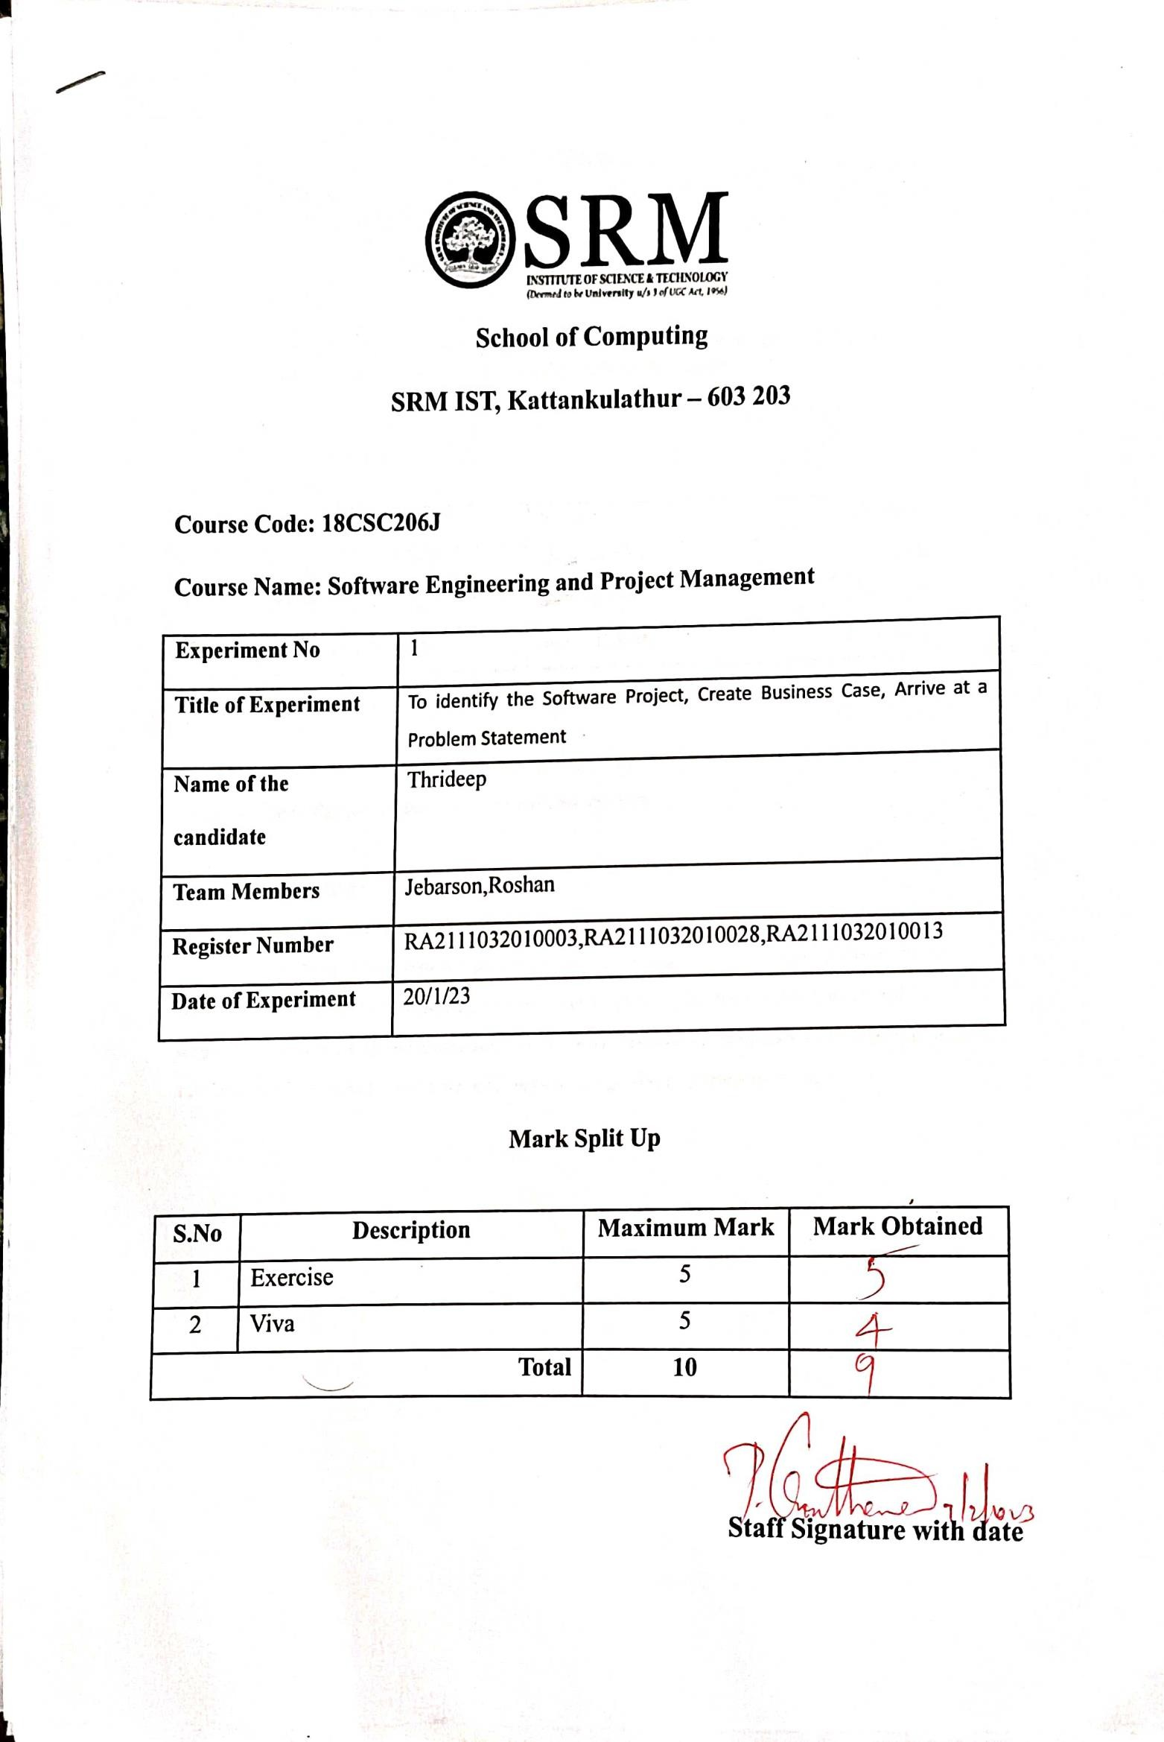







|  |  |  |  |
| --- | --- | --- | --- |
|  |  |  |  |
|  |  |  |  |
|  |  |  |  |
|  |  |  |  |





2



|  |  |  |
| --- | --- | --- |
|  |  |  |
|  |  |  |
|  |  |  |

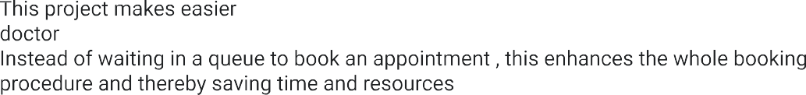

3









     



4

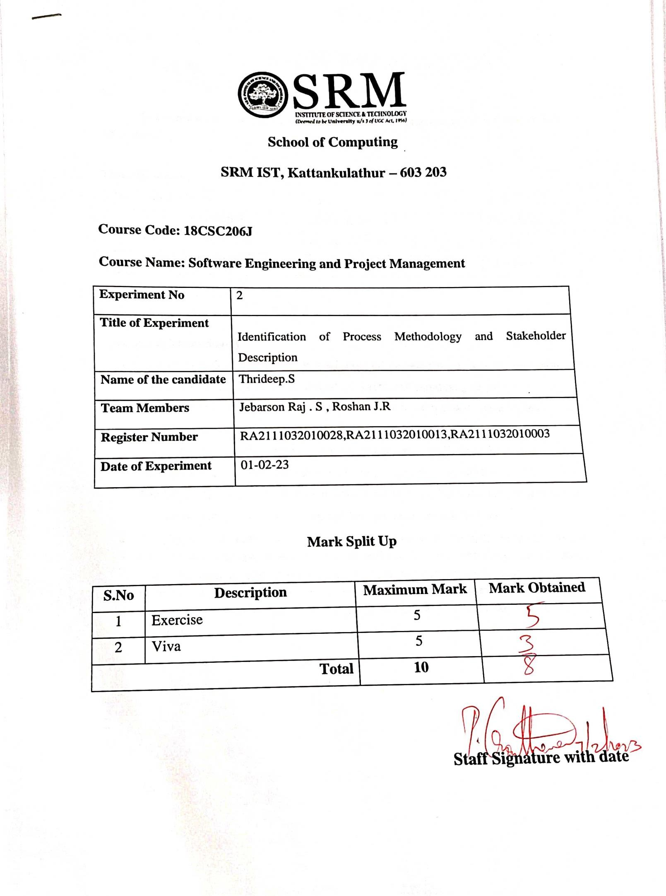

RA2111032010003









|  |  |  |  |
| --- | --- | --- | --- |
|  |  |  |  |
|  |  |  |  |
|  |  |  |  |
|  |  |  |  |

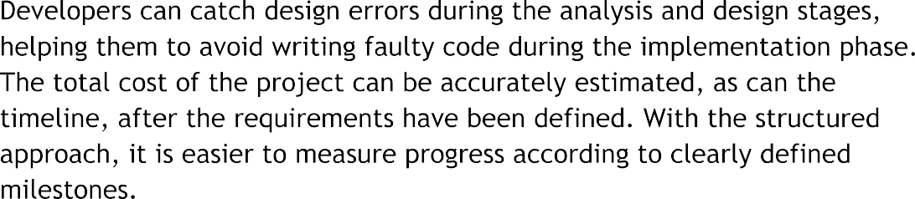



6

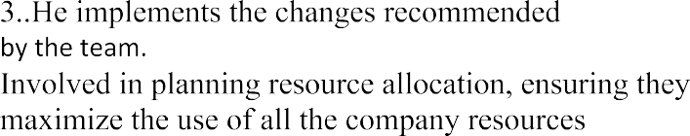 

|  |  |  |  |  |
| --- | --- | --- | --- | --- |
|  |  |  |  |  |
|  |  |  |  |  |
|  |  |  |  |  |
|  |  |  |  |  |
|  |  |  |  |  |
|  |  |  |  |  |
|  |  |  |  |  |
|  |  |  |  |  |
|  |  |  |  |  |





7

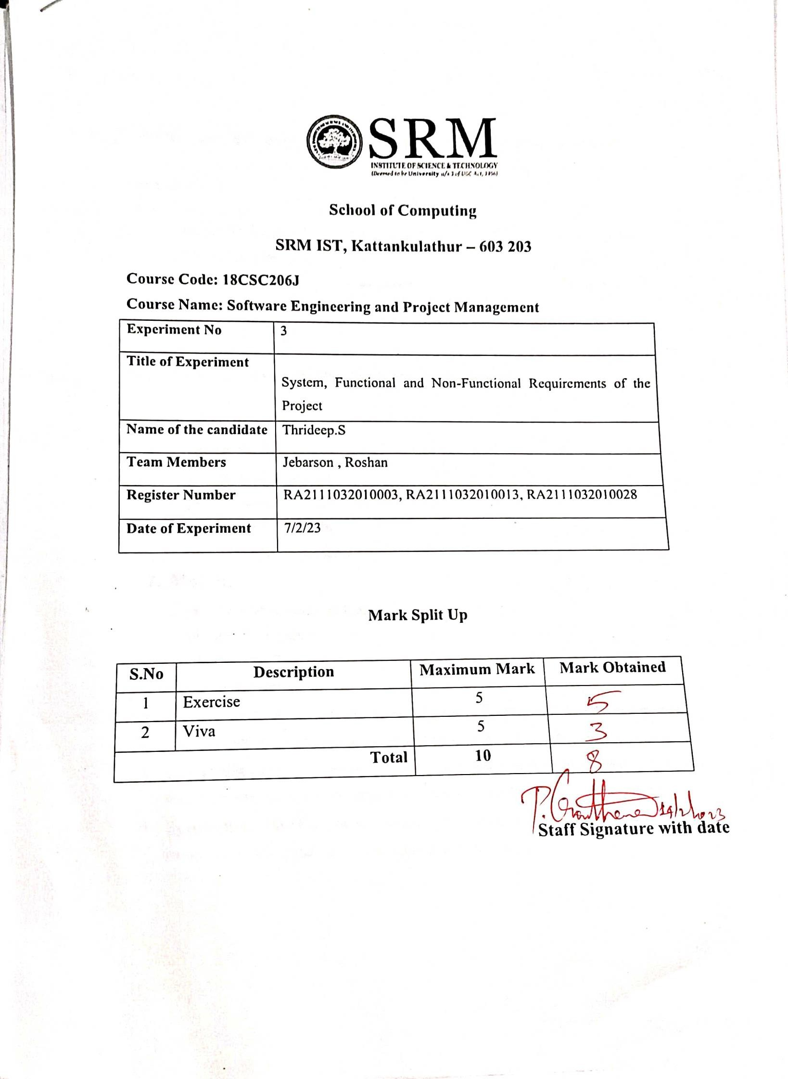







|  |  |  |  |
| --- | --- | --- | --- |
|  |  |  |  |
|  |  |  |  |
|  |  |  |  |
|  |  |  |  |









9













10

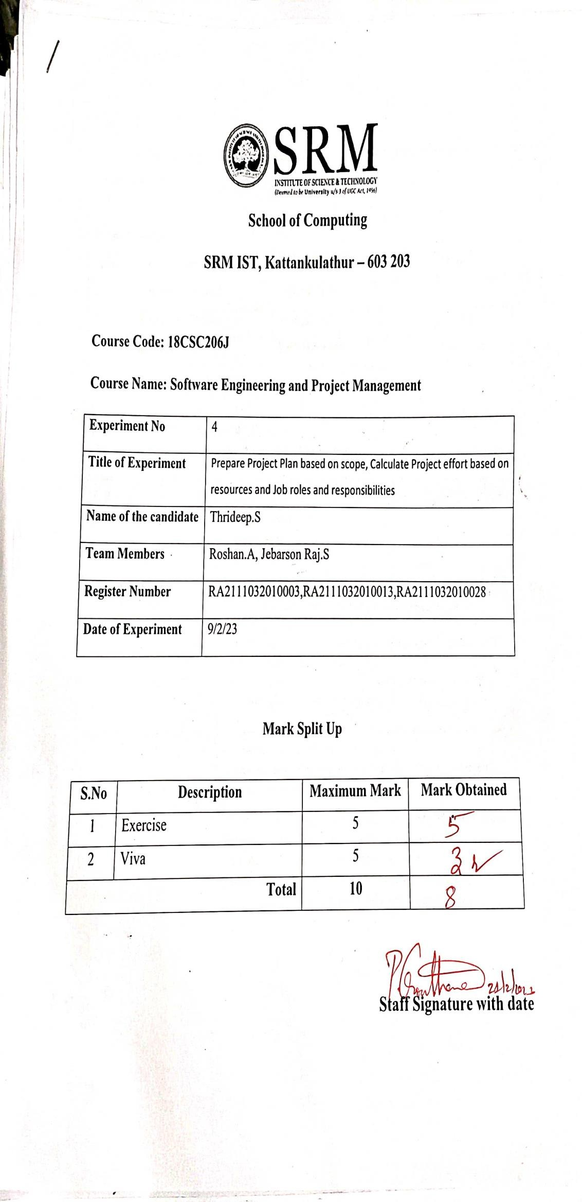







|  |  |  |  |
| --- | --- | --- | --- |
|  |  |  |  |
|  |  |  |  |
|  |  |  |  |
|  |  |  |  |







12

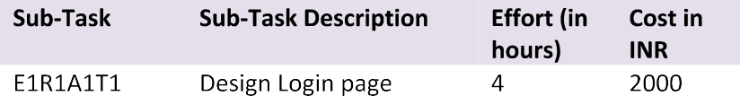  



|  |  |  |  |  |
| --- | --- | --- | --- | --- |
|  |  |  |  |  |
|  |  |  |  |  |
|  |  |  |  |
|  |  |  |  |
|  |  |  |  |  |
|  |  |  |  |
|  |  |  |  |  |
|  |  |  |  |  |
|  |  |  |  |  |
|  |  |  |  |  |
|  |  |  |  |  |
|  |  |  |  |  |

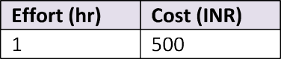



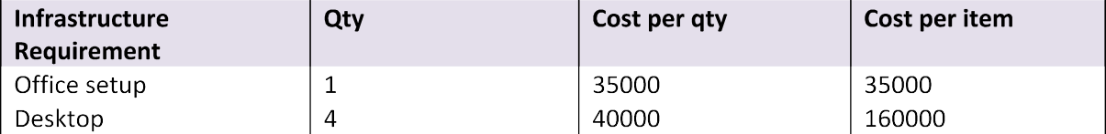



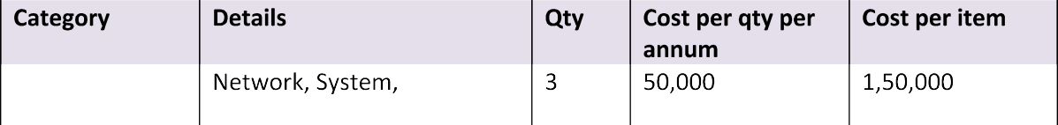

|  |  |  |  |  |
| --- | --- | --- | --- | --- |
|  |  |  |  |  |
|  |  |  |  |  |
|  |  |  |  |  |

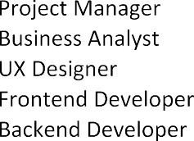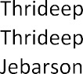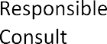

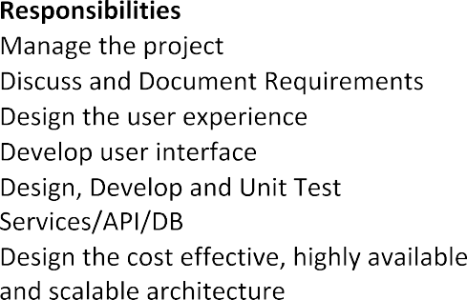





|  |  |  |
| --- | --- | --- |
|  |  |  |
|  |  |  |
|  |  |  |
|  |  |  |
|  |  |  |
|  |  |  |
|  |  |  |
|  |  |  |

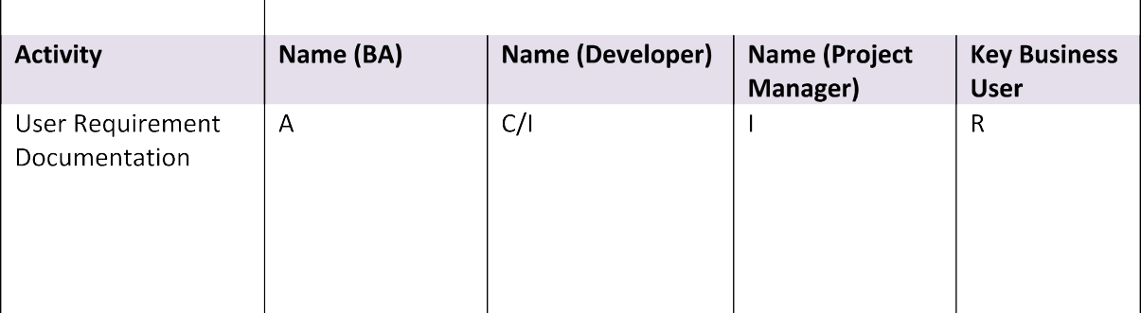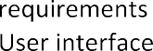

|  |  |
| --- | --- |
|  |  |
|  |  |
|  |  |
|  |  |



14

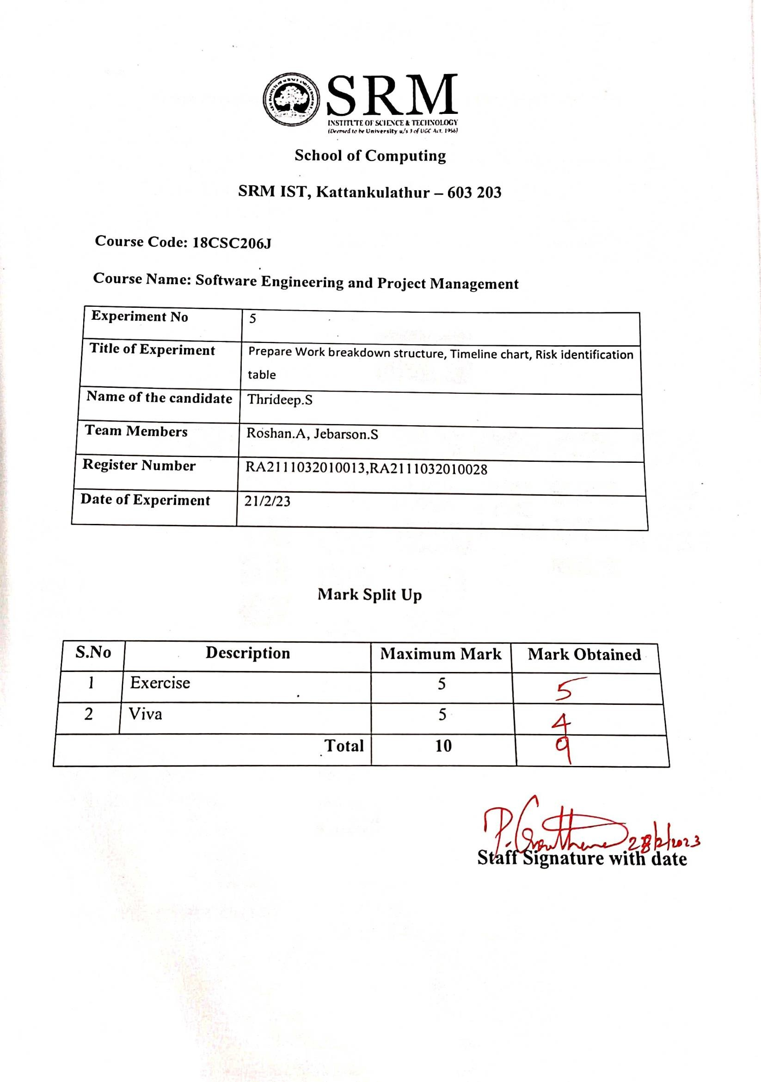

RA2111032010003







|  |  |  |  |
| --- | --- | --- | --- |
|  |  |  |  |
|  |  |  |  |
|  |  |  |  |
|  |  |  |  |



16

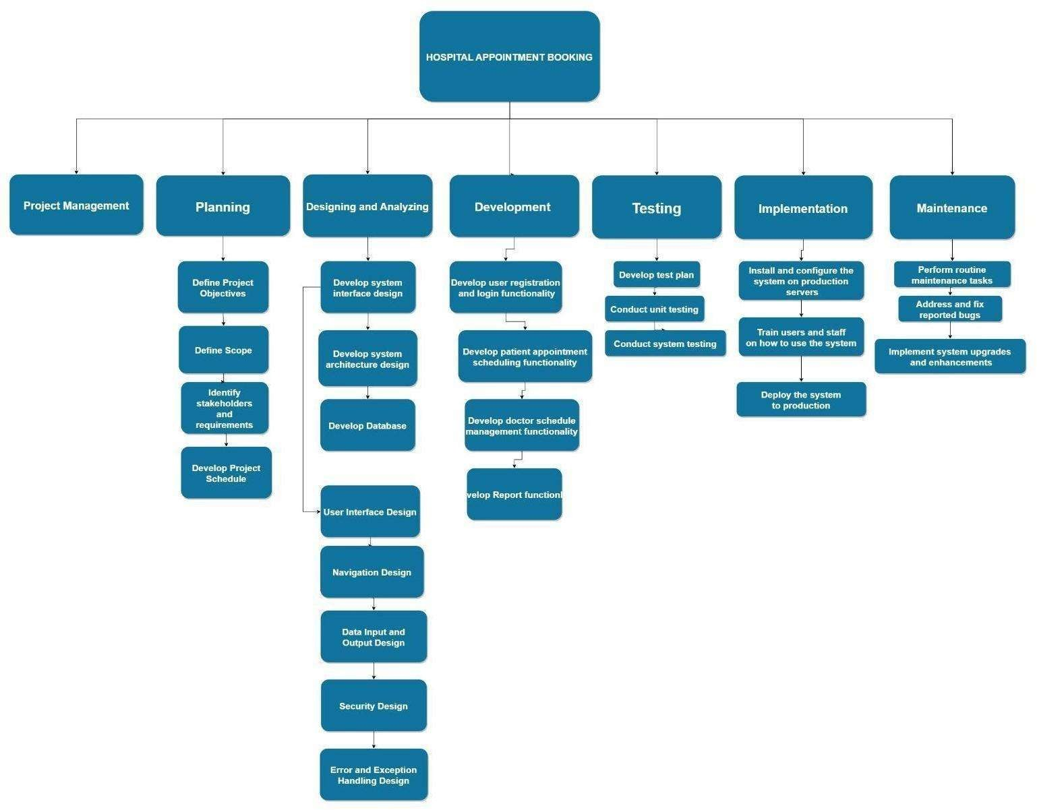



17

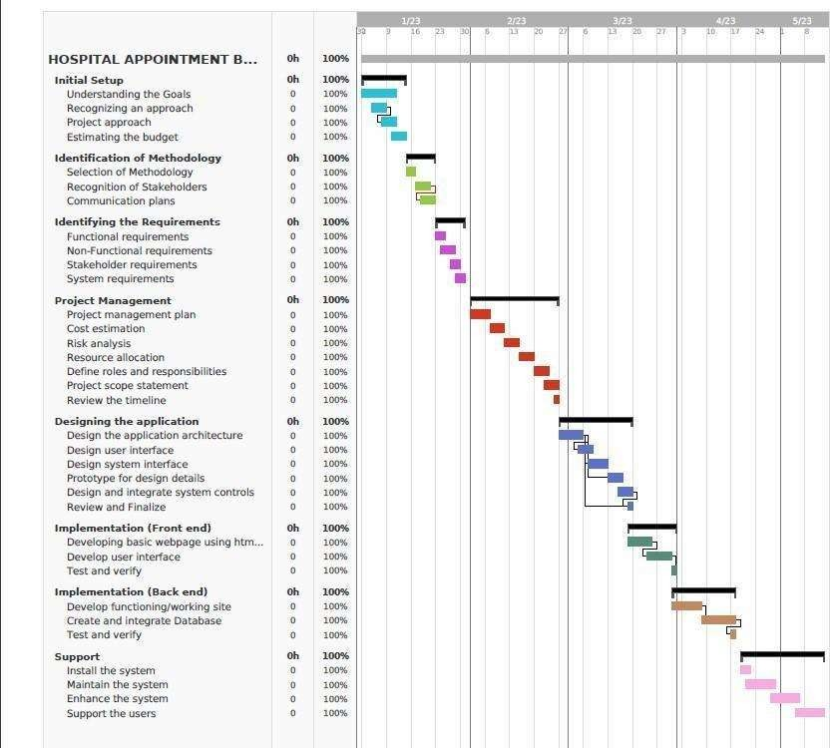

18

 

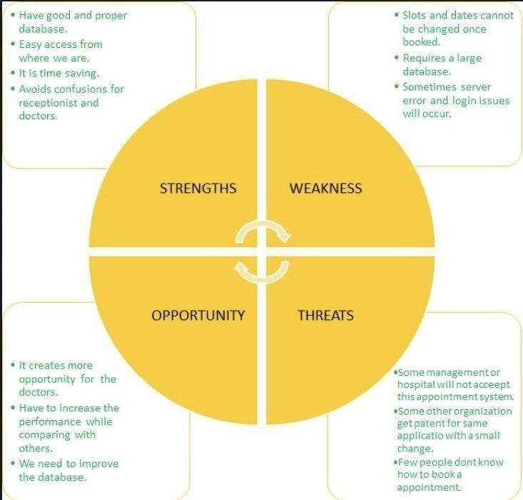





|  |  |  |
| --- | --- | --- |
|  |  |  |
|  |  |  |
|  |  |  |
|  |  |  |

|  |  |  |
| --- | --- | --- |
|  |  |  |



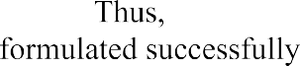

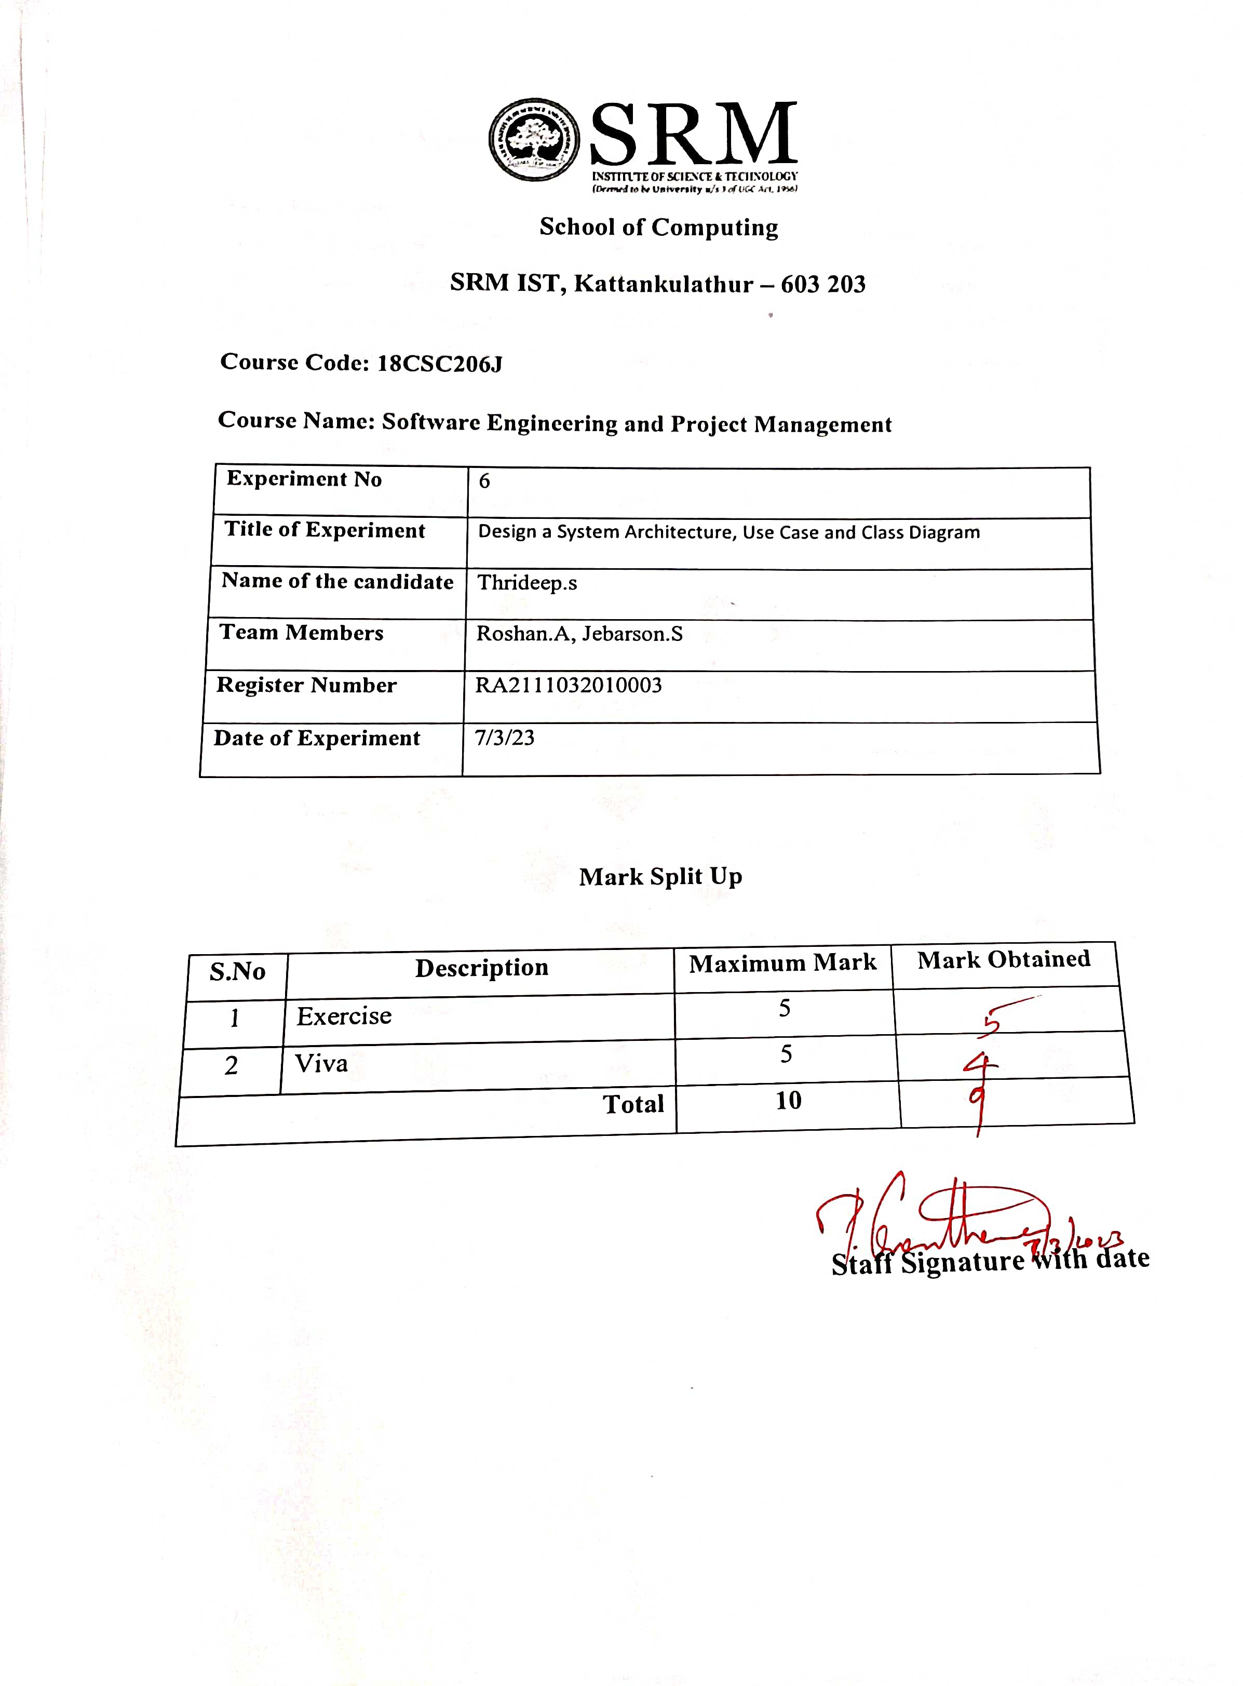







|  |  |  |  |
| --- | --- | --- | --- |
|  |  |  |  |
|  |  |  |  |
|  |  |  |  |
|  |  |  |  |





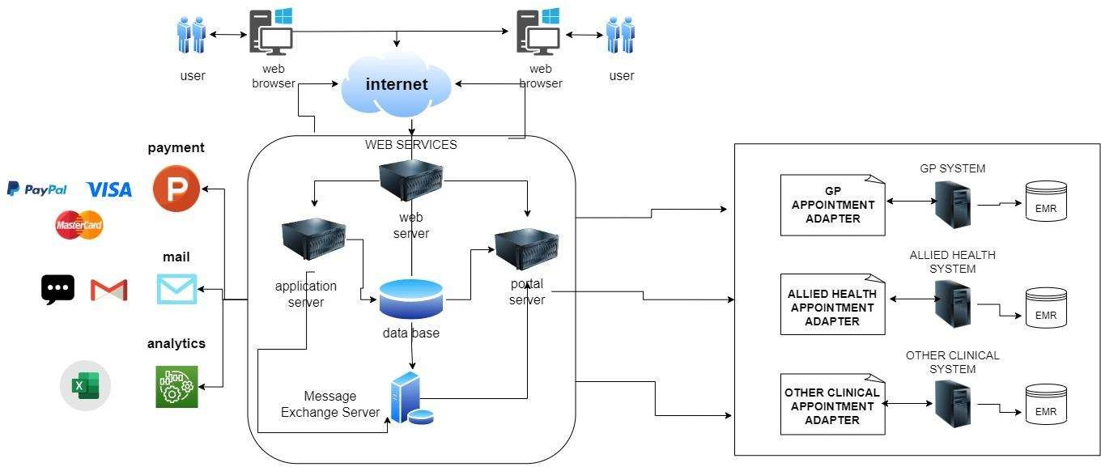



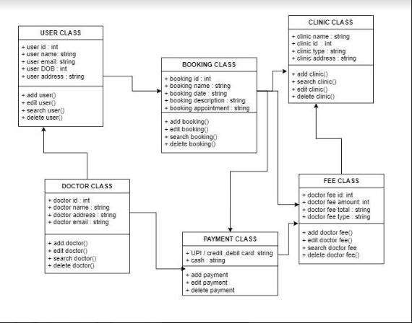



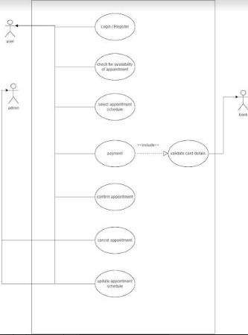





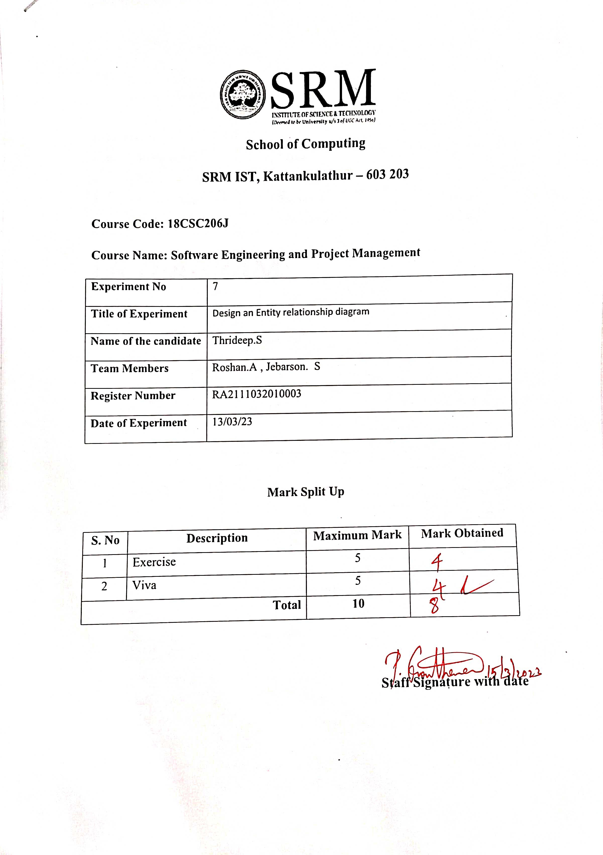







|  |  |  |  |
| --- | --- | --- | --- |
|  |  |  |  |
|  |  |  |  |
|  |  |  |  |
|  |  |  |  |



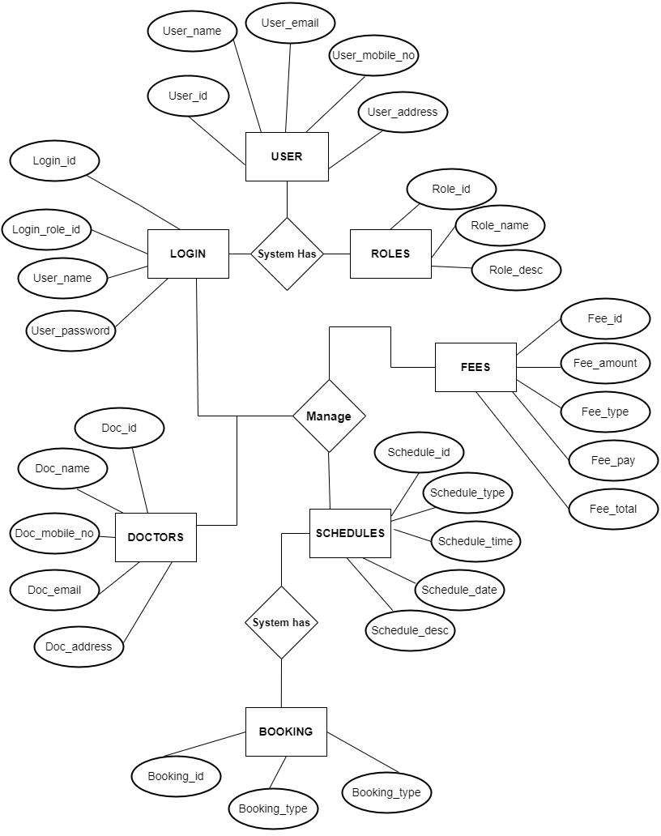





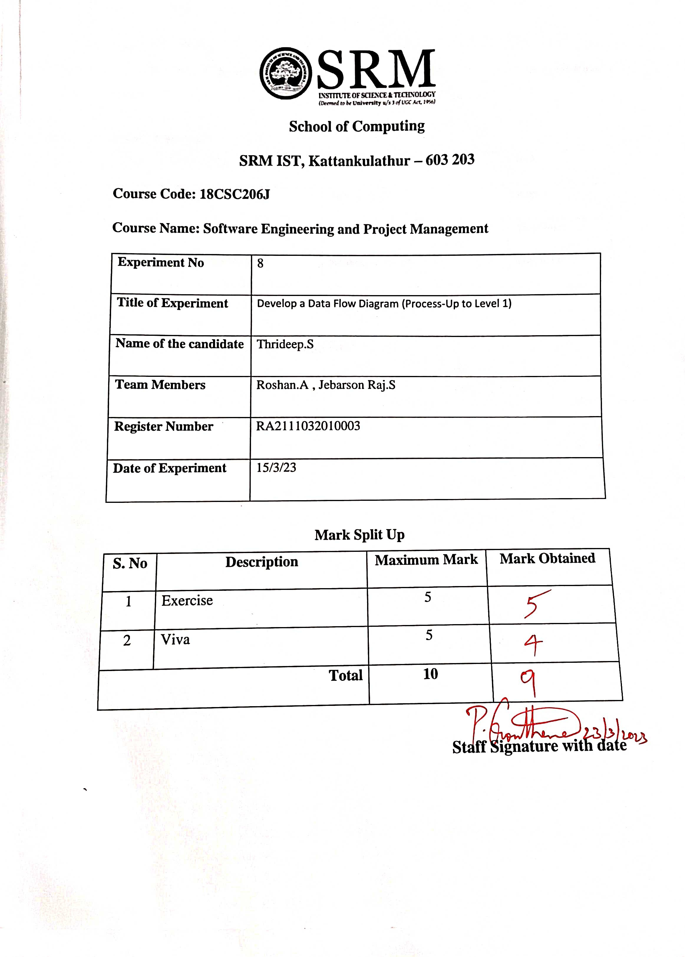







|  |  |  |  |
| --- | --- | --- | --- |
|  |  |  |  |
|  |  |  |  |
|  |  |  |  |
|  |  |  |  |





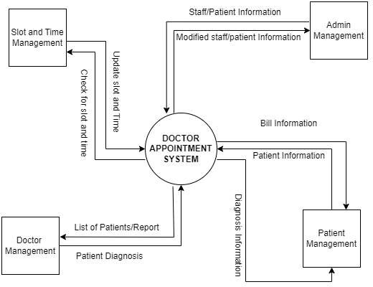

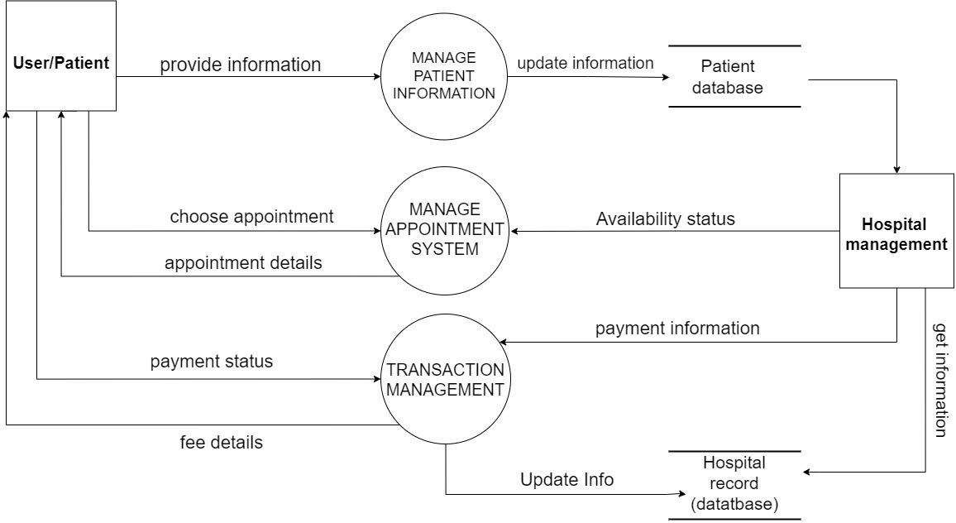



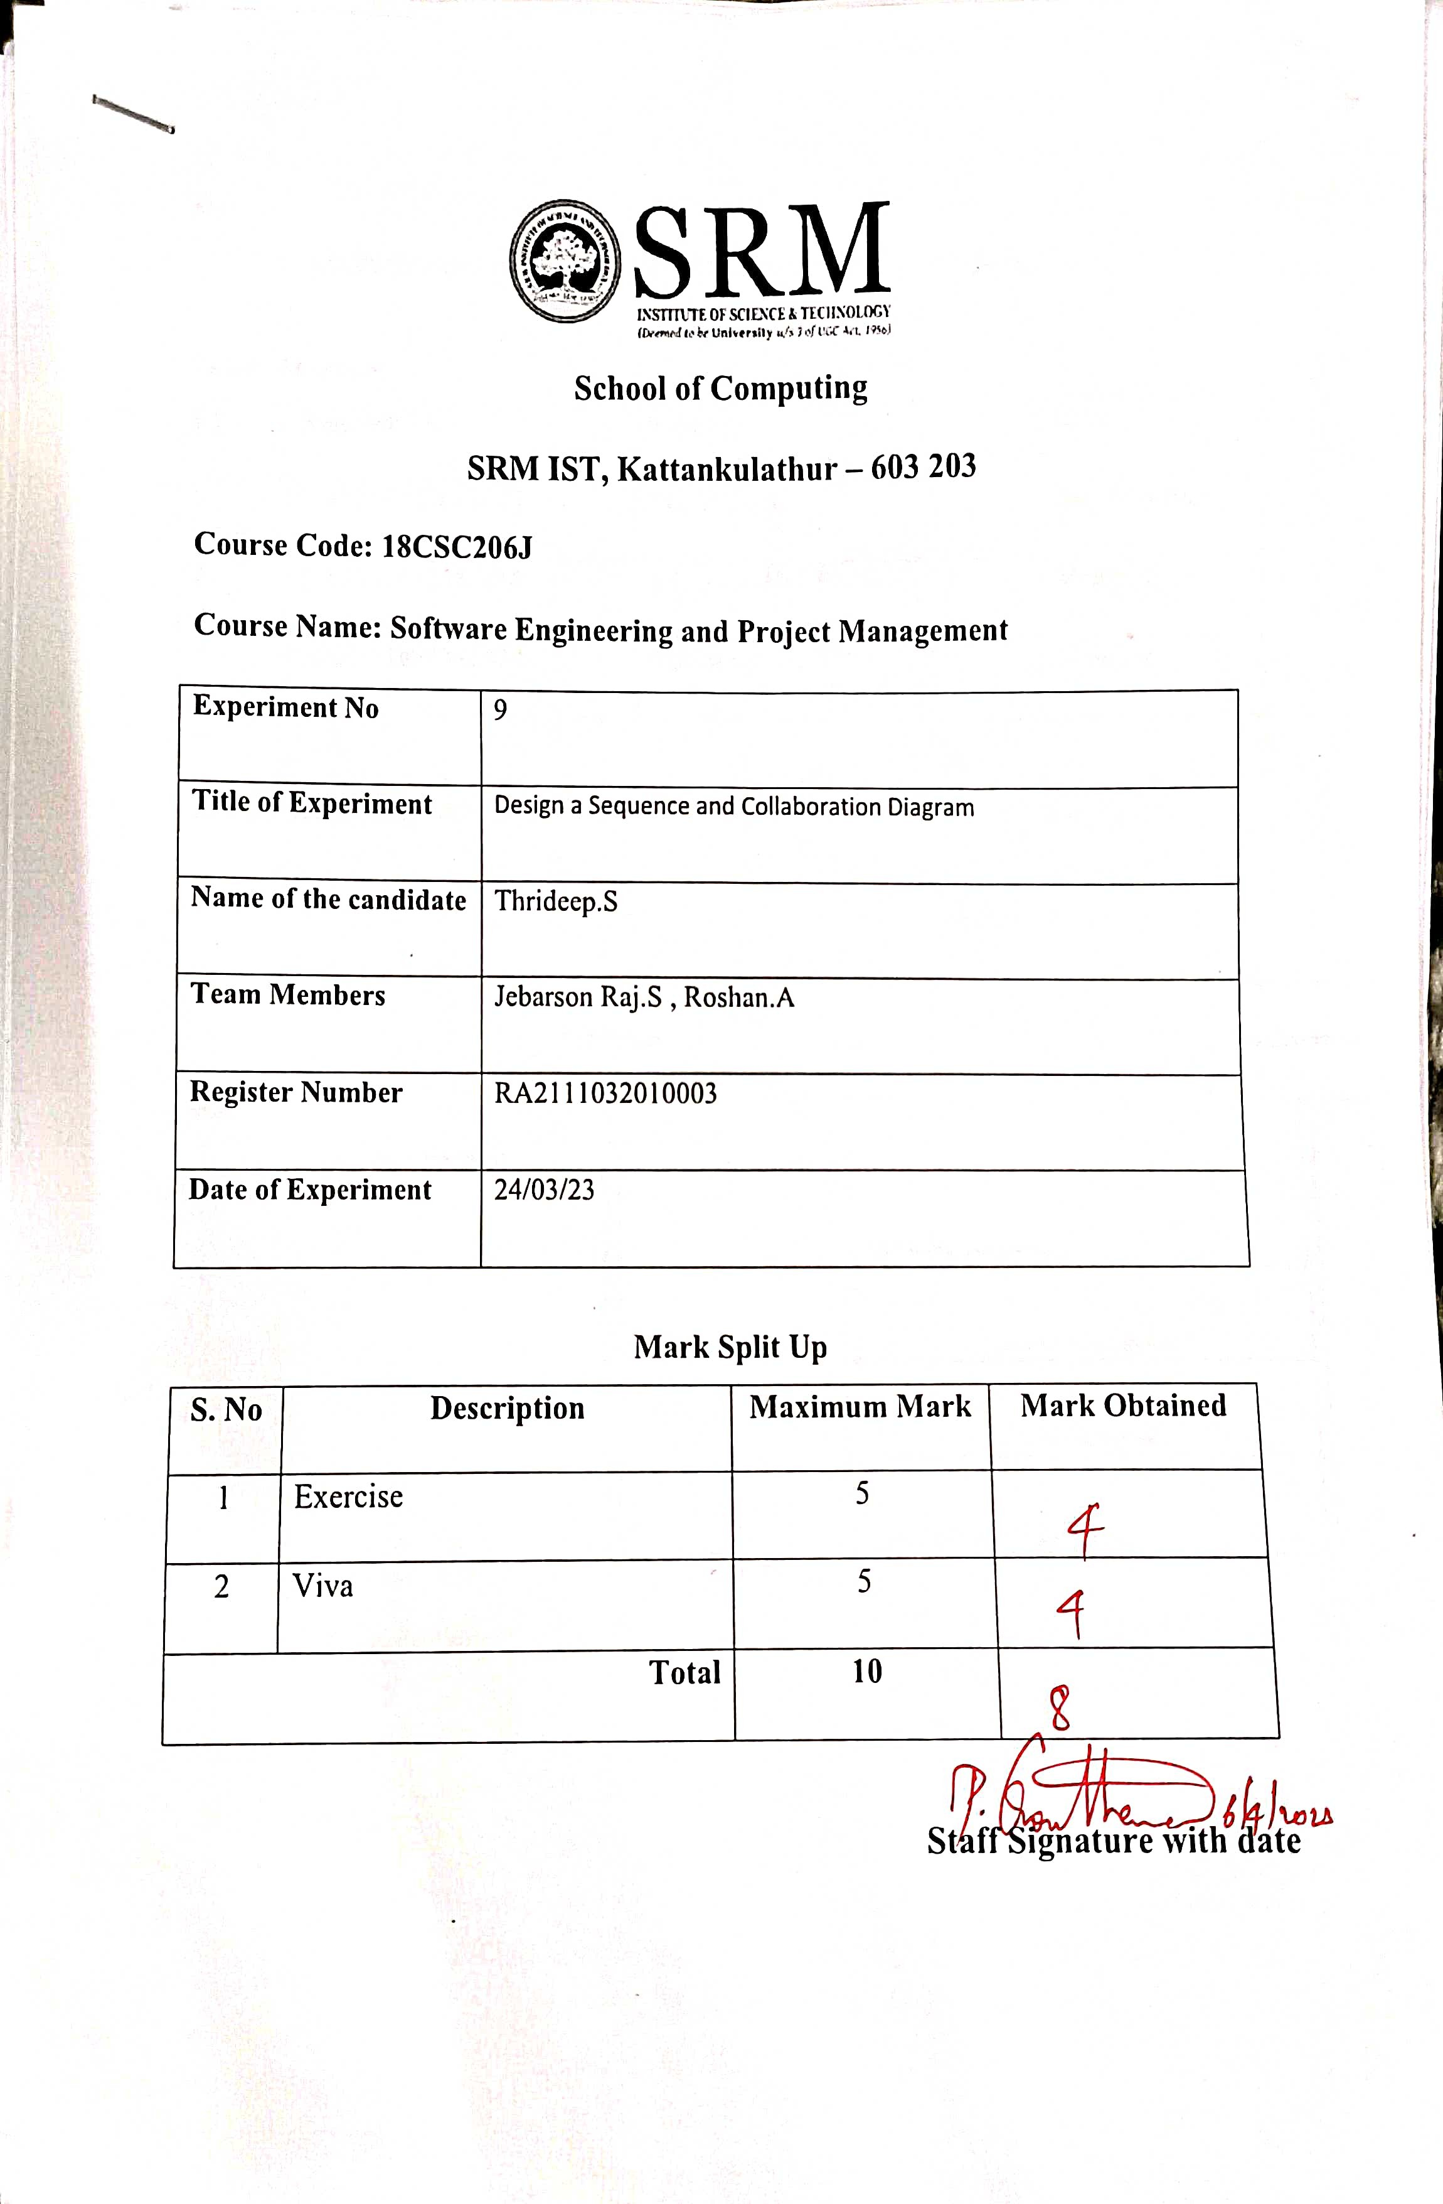







|  |  |  |  |
| --- | --- | --- | --- |
|  |  |  |  |
|  |  |  |  |
|  |  |  |  |
|  |  |  |  |



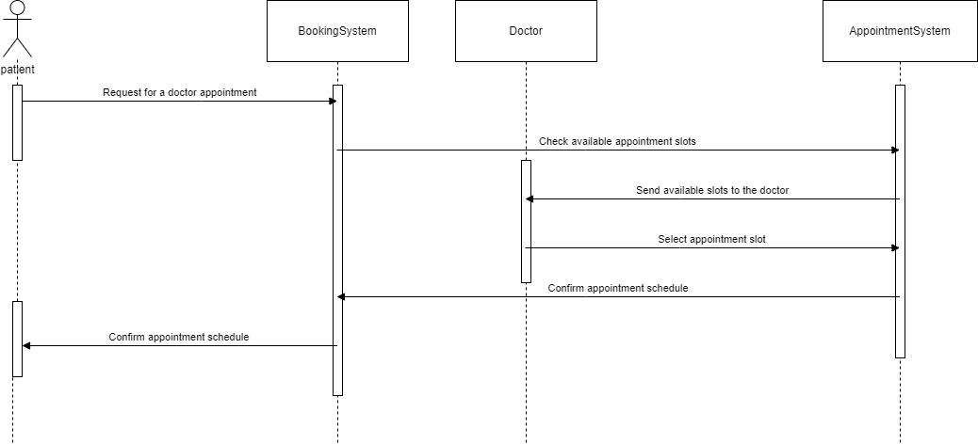



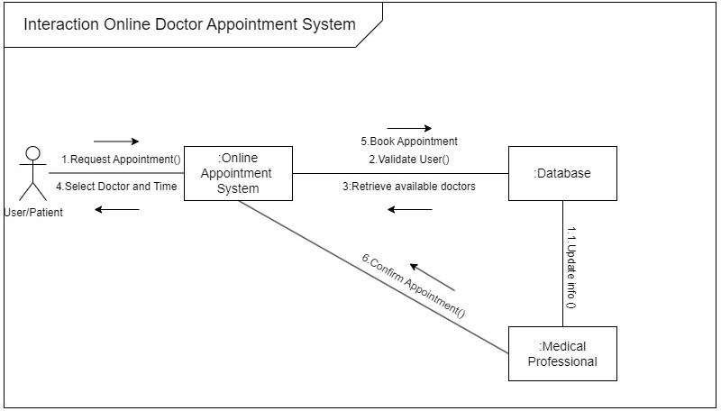



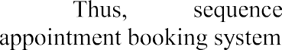

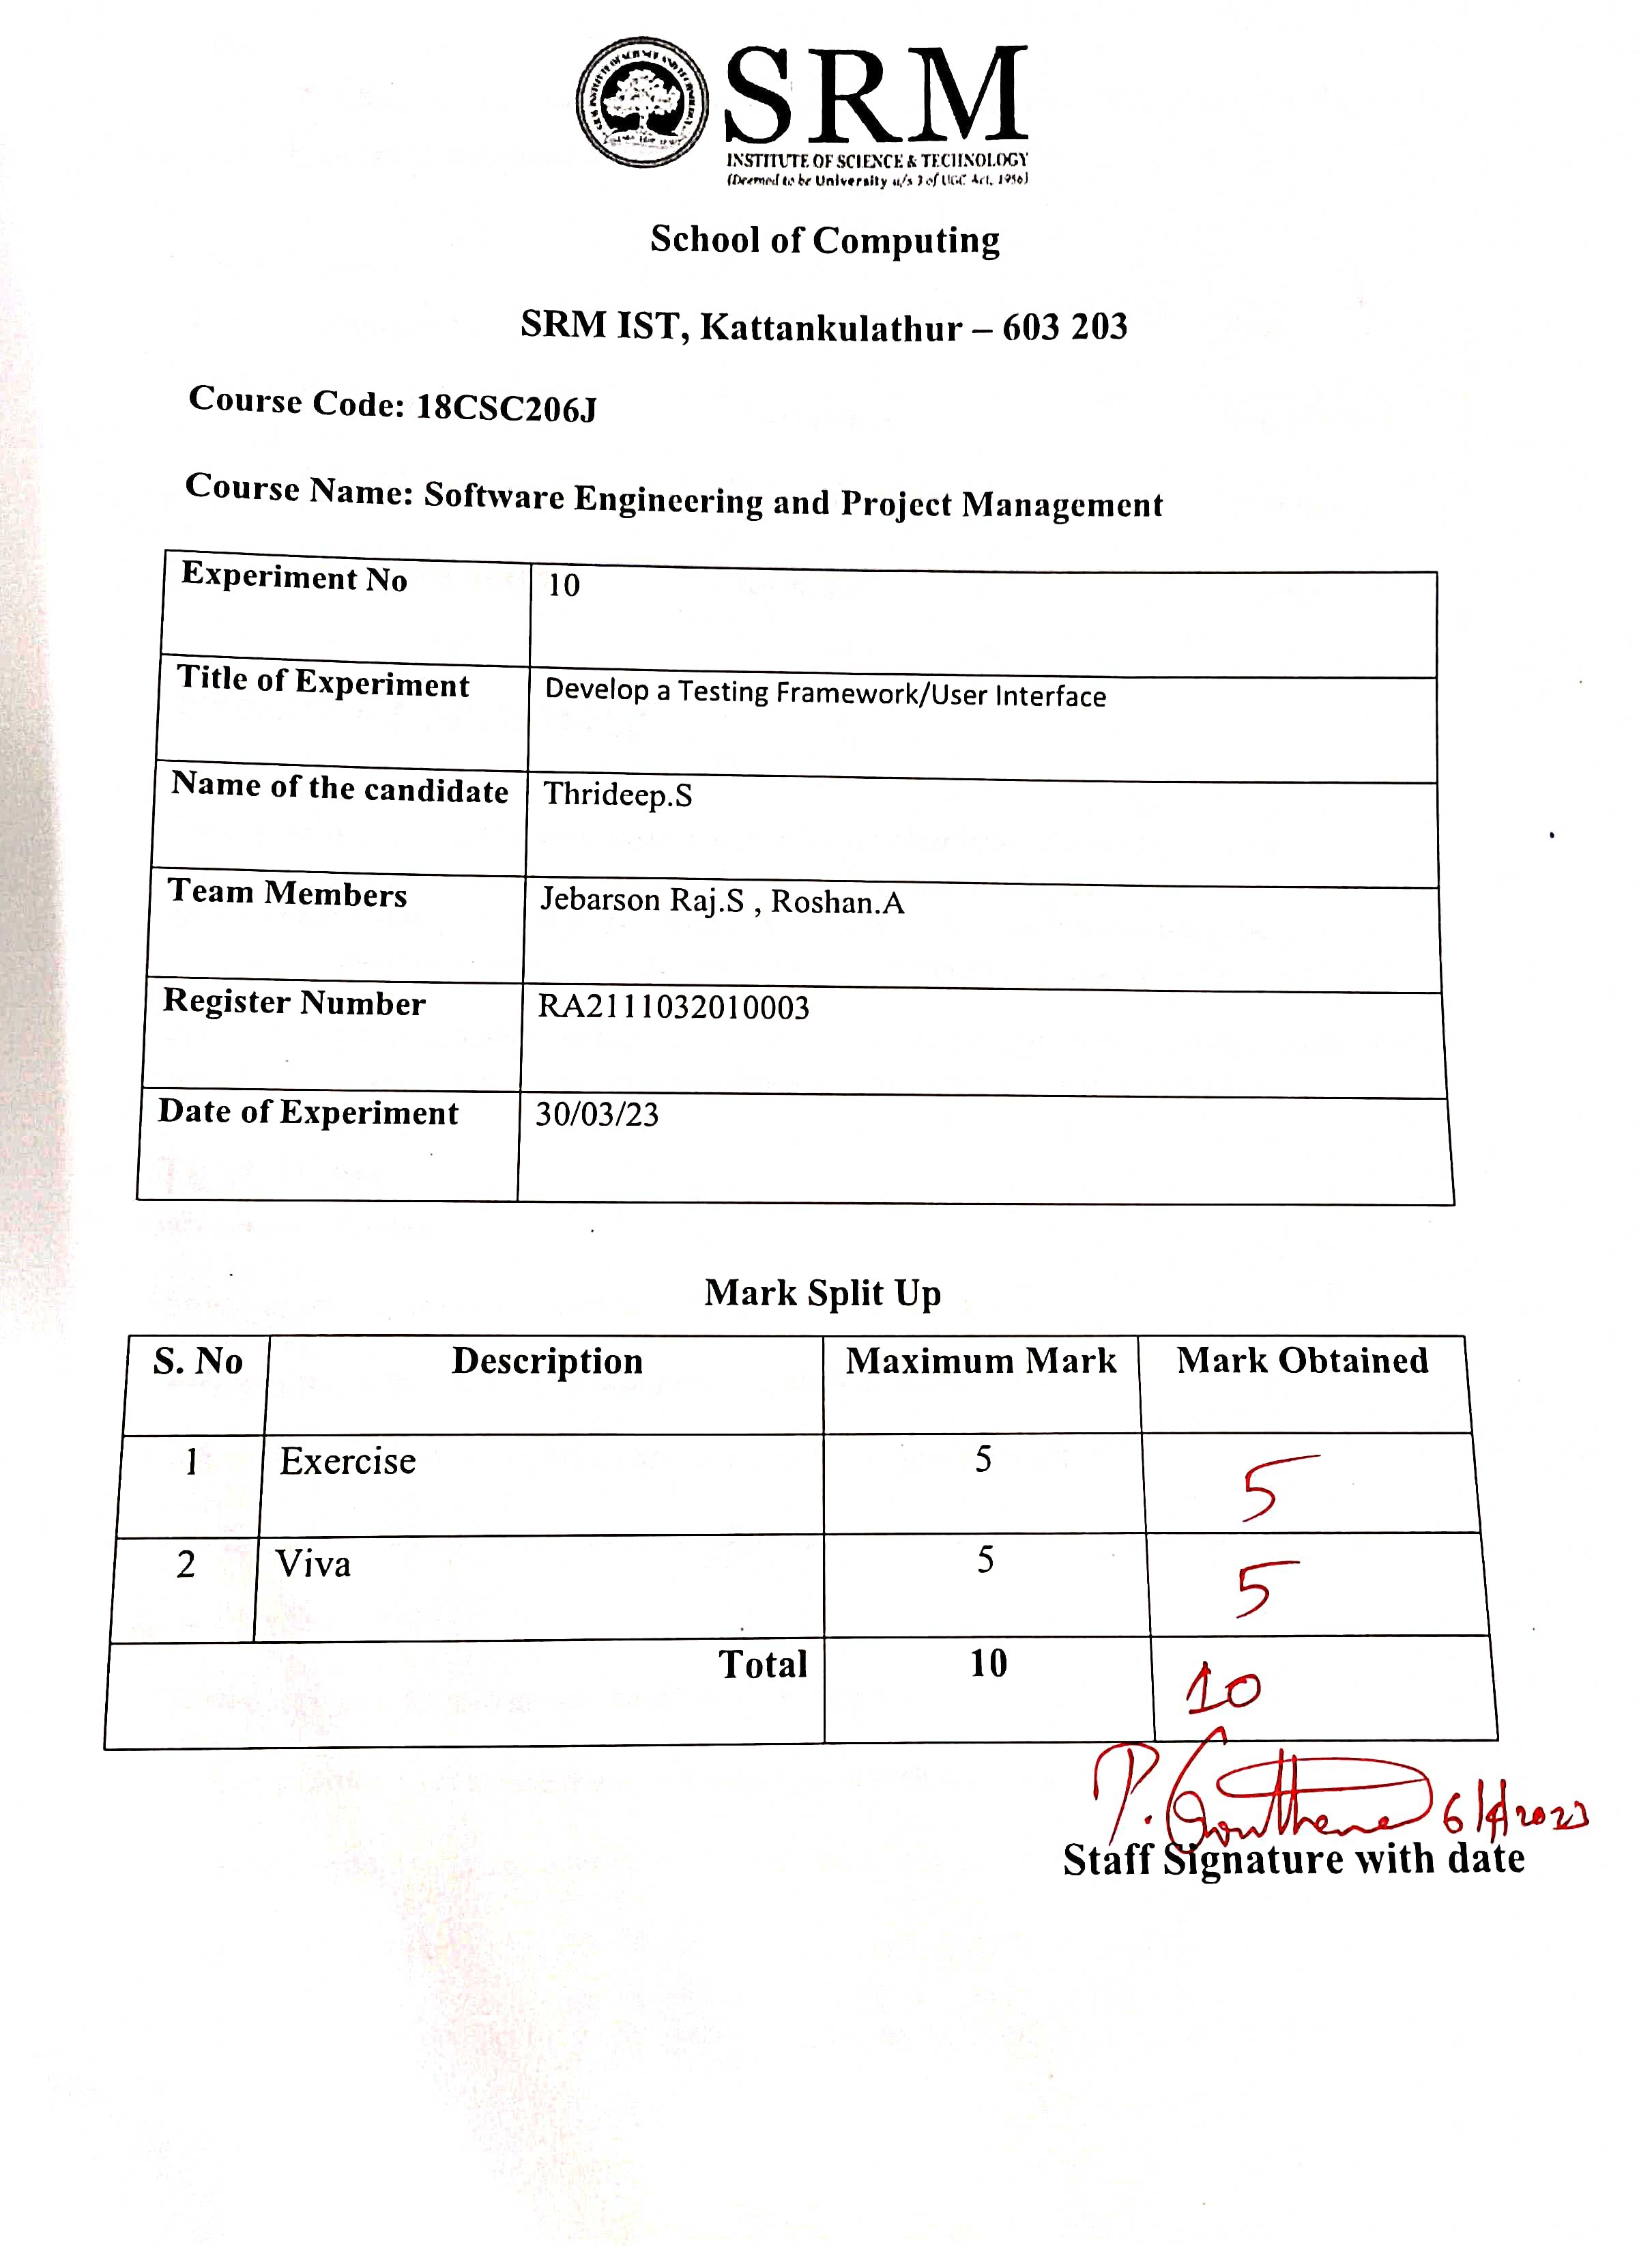







|  |  |  |  |
| --- | --- | --- | --- |
|  |  |  |  |
|  |  |  |  |
|  |  |  |  |
|  |  |  |  |





























 



|  |  |  |
| --- | --- | --- |
|  |  |  |
|  |  |  |
|  |  |  |
|  |  |  |
|  |  |  |



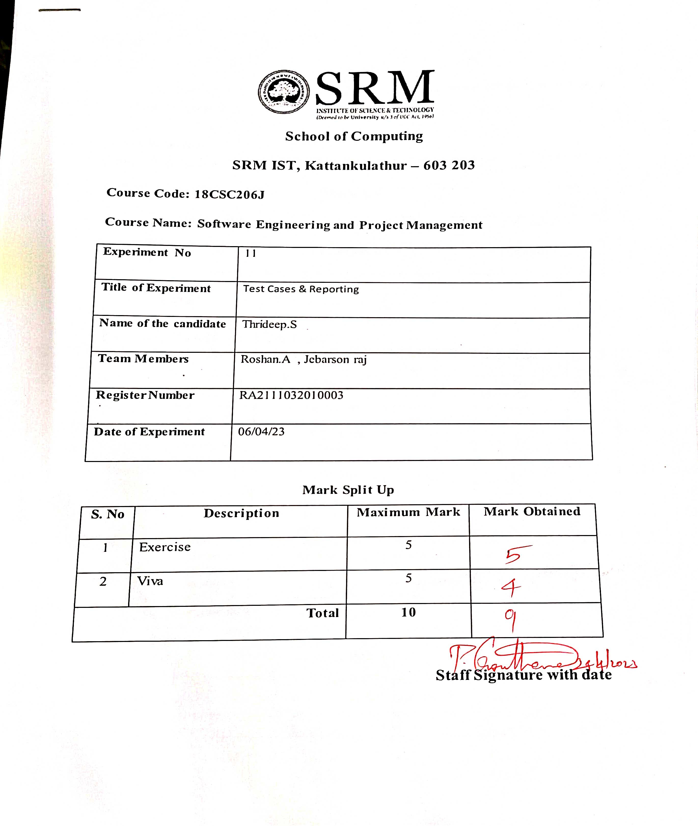



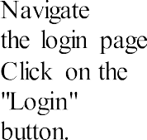





|  |  |  |  |
| --- | --- | --- | --- |
|  |  |  |  |
|  |  |  |  |
|  |  |  |  |
|  |  |  |  |







|  |  |  |  |  |  |  |  |  |
| --- | --- | --- | --- | --- | --- | --- | --- | --- |
|  |  |  |  |  | |  |  |  |
|  |  |  |  |  |  |  |  |  |
|  | |
|  |  |  |  |  | |  |  |  |
|  |  |  |  |  | |  |  |  |

|  |  |  |  |  |  |  |  |
| --- | --- | --- | --- | --- | --- | --- | --- |
|  |  |  |  |  |  |  |  |
|  |  |  |  |  |  |  |  |

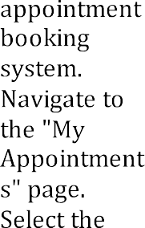







|  |  |  |  |  |  |  |  |
| --- | --- | --- | --- | --- | --- | --- | --- |
|  |  |  |  |  |  |  |  |
|  |  |  |  |  |  |  |  |

|  |  |  |  |  |  |  |  |
| --- | --- | --- | --- | --- | --- | --- | --- |
|  |  |  |  |  |  |  |  |
|  |  |  |  |  |  |  |  |



|  |  |  |
| --- | --- | --- |
|  |  |  |
|  |  |  |
|  |  |  |





 

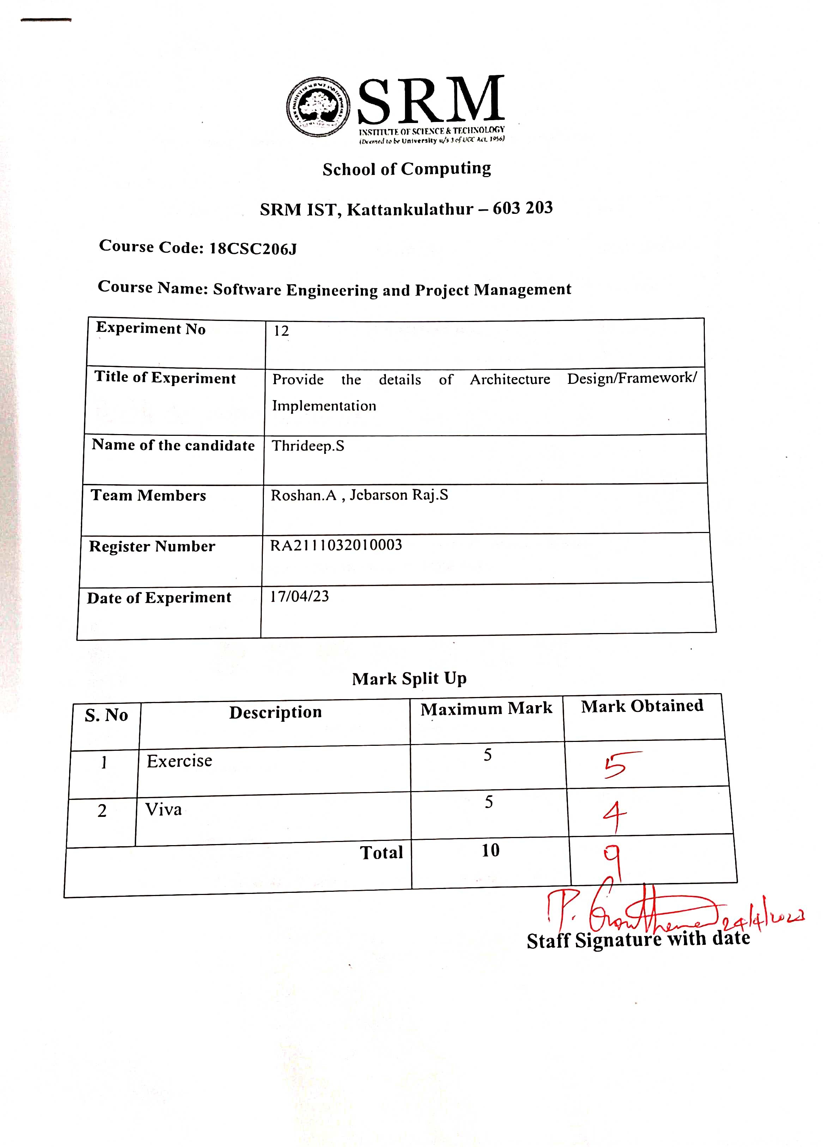







|  |  |  |  |
| --- | --- | --- | --- |
|  |  |  |  |
|  |  |  |  |
|  |  |  |  |
|  |  |  |  |



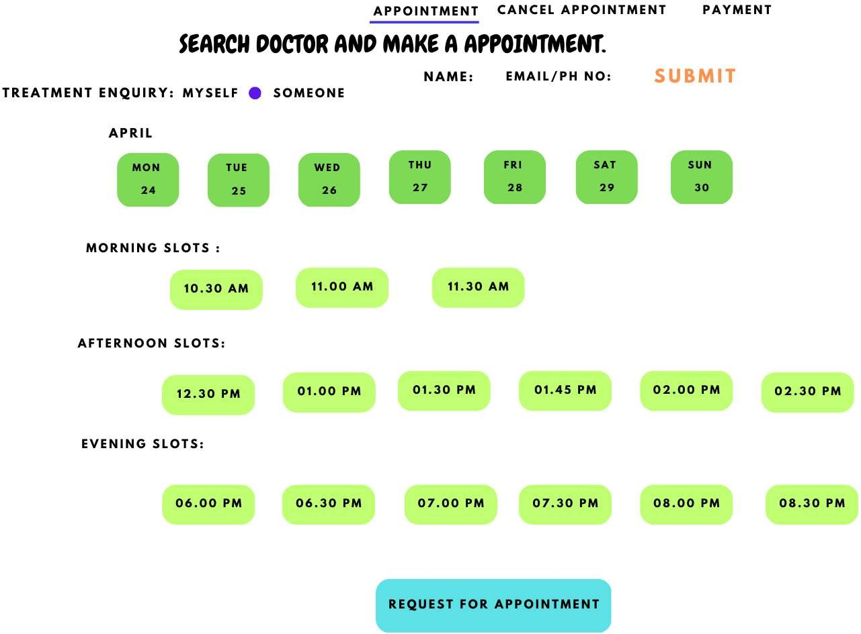



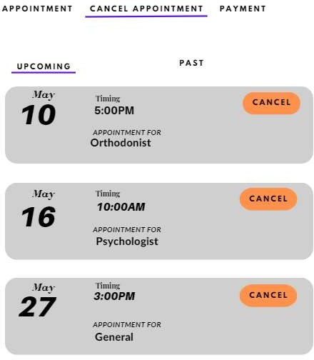



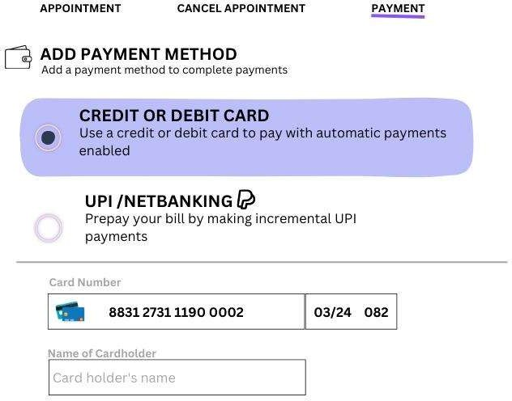





**CONCLUSION**

In conclusion, an online doctor appointment booking system is a convenient and efficient solution for both patients and healthcare providers. It simplifies the appointment scheduling process, saves time, and provides easy access to medical consultations. The system is designed to be user-friendly, with features such as doctor search, appointment booking, online payments, and appointment reminders. Healthcare providers can also benefit from the system by having a centralized platform to manage their appointments, optimize scheduling, and improve the overall efficiency of their practice. Overall, an online doctor appointment booking system is a valuable tool that can enhance patient experiences and improve the delivery of healthcare services.

**REFERENCES**

[1] Roger S. Pressman, Software Engineering - A Practioner Approach, 6th ed., McGraw Hill, 2005

[2] Ian Sommerville, Software Engineering, 8th ed., Pearson Education, 2010

[3] TeamGantt, What is a Gantt Chart? A Step-by-Step Guide [Online]. Available: <https://www.teamgantt.com/what-is-a-gantt-chart>

[4] Caroline Forsey, HubSpot (2023), SWOT Analysis: How To Do One [Online]. Available: <https://blog.hubspot.com/marketing/swot-analysis>

[5] Craig Larmen, Applying UML and Patterns, 3rd ed., Prentice Hall, 2004

[6] create-t3-app, Why CT3A? [Online]. Available: <https://create.t3.gg/en/why>

[7] Lucidchart, What is an Entity Relationship Diagram [Online]. Available: <https://www.lucidchart.com/pages/er-diagrams>

[8] Lucidchart, Data Flow Diagram Symbols [Online]. Available:

<https://www.lucidchart.com/pages/data-flow-diagram/data-flow-diagram-symbols>

[9] Jonathan Saring, Medium (2019), 11 Tools and Libraries for Testing in React [Online]. Available: <https://blog.bitsrc.io/7-react-testing-libraries-you-should-know-b20ca97422a4>

[10] Suhani Jain, BrowserStack (2023), What is Non-Functional Testing [Online]. Available: <https://www.browserstack.com/guide/what-is-non-functional-testing>